Health Sciences Building Map

GB03 – Lecture theater
GB01 – B-wing Foyer – Light Breakfast & Coffee Breaks
GD07 – Atrium – Light Breakfast, Coffee Breaks, Lunches
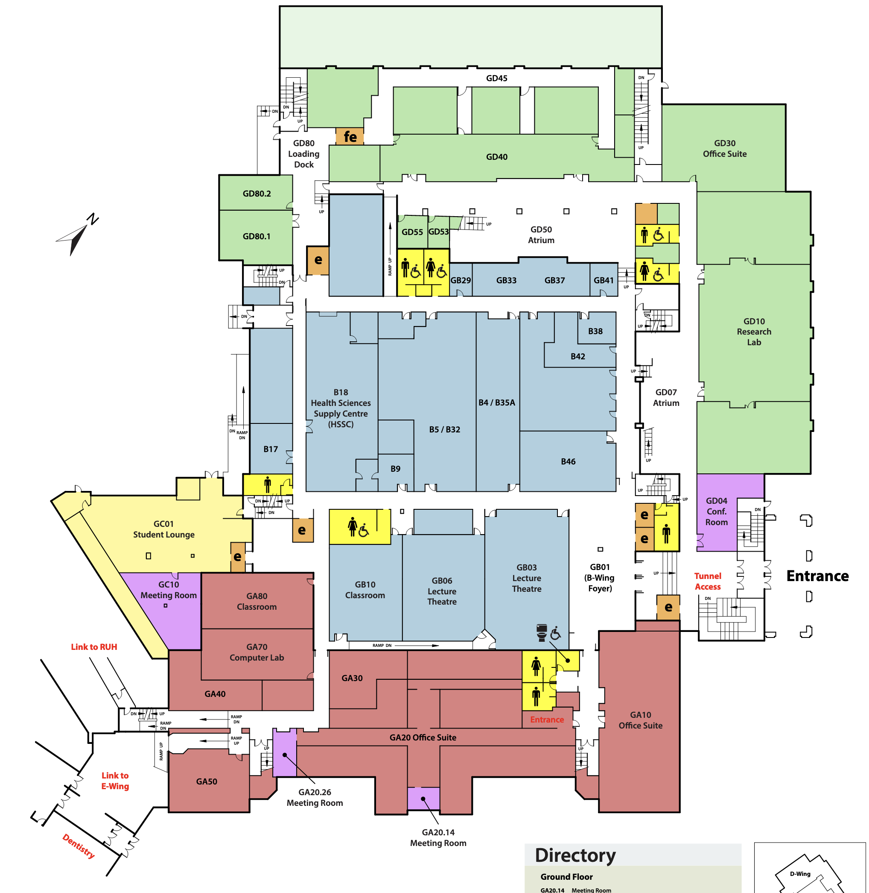
GD50 – Atrium – Lunches

